**St. Xavier’s College**

**(Affiliated to Tribhuvan University)**

**Maitighar, Kathmandu**



**COMPUTER GRAPHICS**

**LAB ASSIGNMENT #1**

**TO DRAW A CHECKBOX**

**Submitted By**

Linus Dhakal

013BSCCSIT022

**Submitted To**

|  |  |
| --- | --- |
| Er. Anil K Shah  Lecturer, St. Xavier’s College |  |

**Date of Submission:** 4th August 2015

**STATEMENT: TO DRAW A CHECKBOX.**

**SOURCE CODE:**

//---------------------------------------------------------------------------

#include <vcl\vcl.h>

#pragma hdrstop

#include "Unit1.h"

//---------------------------------------------------------------------------

#pragma resource "*.dfm"

TForm1 *Form1;

//---------------------------------------------------------------------------

__fastcall TForm1::TForm1(TComponent* Owner)

: TForm(Owner)

{

}

//---------------------------------------------------------------------------

void __fastcall TForm1::Button1Click(TObject *Sender)

{

Image1->Canvas->Pen->Width=3;

Image1->Canvas->Brush->Color=clMaroon;

Image1->Canvas->Rectangle(10,10,200,200);

Image1->Canvas->MoveTo(10,10);

Image1->Canvas->LineTo(200,200);

Image1->Canvas->MoveTo(200,10);

Image1->Canvas->LineTo(10,200);

Image1->Canvas->MoveTo(105,10);

Image1->Canvas->LineTo(105,200);

Image1->Canvas->MoveTo(10,105);

Image1->Canvas->LineTo(200,105);

Image1->Canvas->MoveTo(57.5,10);

Image1->Canvas->LineTo(57.5,200);

Image1->Canvas->MoveTo(152.5,10);

Image1->Canvas->LineTo(152.5,200);

Image1->Canvas->MoveTo(10,57.5);

Image1->Canvas->LineTo(200,57.5);

Image1->Canvas->MoveTo(10,152.5);

Image1->Canvas->LineTo(200,152.5);}

//---------------------------------------

**OUTPUT:**

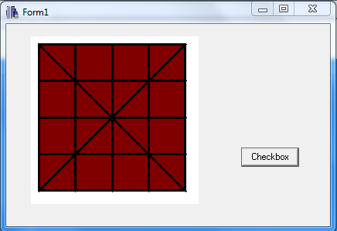

**CONCLUSION:**

Hence, a checkbox was drawn using C++ builder; a general computer graphics program. If any changes were to be made, then, the changes could be implemented with simple changes in the source code.

**REFERENCE:**

[1] <http://www.embarcadero.com/products/cbuilder>